CHESAPEAKE BAY PRESERVATION AREAS AND STREAM PROTECTION AREAS (Chapter 6)
- The following land features are present on the site and must be accurately shown on the plans:
Resource Protection Area (RPA)
Resource Management Area (RMA)
Stream Protection Area (SPA) (non-RPA and 100 acres or more of drainage)

- Add stream location to plans
- Clarify RPA/SPA

- A RPA appears to exist on the site associated with a perennial stream that has not been previously identified as such. In accordance with County Code, RPA rules apply to the stream. Under this circumstance, appropriate evidence will need to be provided to claim that the stream is not perennial and that RPA rules do not apply.
- The RPA buffer must be forested/reforested.
- The SPA must be forested/reforested.
- The plan must include reforestation details consistent with Minimum Standard 14.10 of the Environmental Compliance Manual.
- The Resource Protection Area (RPA) limits are shown incorrectly.
- The Resource Management Area (RMA) limits are shown incorrectly. (If the entire site is considered RMA, question #10 on the ESA must be answered as “yes”.)
- The Stream Protection Area (SPA) limits are shown incorrectly.
- Orange safety fence or non-tearable yellow and black barricade tape is required at the limits of the RPA/SPA buffer. It must also be installed around the limits of disturbance for all encroachments/impacts within these areas. Show the location of fence/barricade tape on the plans. The fence/tape must be installed prior to the pre-construction meeting (clearly note this in the ESC narrative).

- Ensure this is everywhere necessary

- There must be a separation equal to or greater than the minimum rear yard setback between the RPA/SPA limits and the rear of the buildable area.
- There must be a separation between the side yard buildable area and the RPA/SPA limits of at least 25 feet, even if the buffer is not located on the lot (common areas, etc.).
- Lots that contain a RPA and/or SPA must be identified with appropriate asterisks ( * ) and notes as stated on page 6-4 of the Henrico County Environmental Compliance Manual.
- A maintenance agreement for the SPA must be provided. A copy of the required maintenance agreement is available from the Department of Public Works. Information and forms for the SPA maintenance agreement can be found at: http://henrico.us/works/forms/ (near the bottom of the page under SPA (Stream Protection Area) Agreement.
- Environmental Protection Area signs are required on all lots containing RPA/SPA. Sign locations must be accurately shown on the plans in accordance with the Sign Spacing, Location, and Installation Guidelines found in section 6.3.3 of the Environmental Compliance Manual.
- The sequence of construction must clarify that the Environmental Protection Area signs must be installed prior to the pre-construction meeting and must be maintained throughout construction.

- Add highlighted language

ADDITIONAL COMMENTS:

ENVIRONMENTAL SITE ASSESSMENT (Chapter 7)
- The completed Environmental Site Assessment (ESA) must be included with the plans. (A complete plan review cannot be accomplished until this information has been provided. Once this information has been received, additional comments may follow.)
- ESA number(s) was (were) answered incorrectly.
- ESA questions should be answered “YES”.
- ESA questions should be answered “NO”.
- All components list as being present on the site must be accurately shown on the plans.
- ESA number(s) have not been accurately shown on the plans.
- The current version of the two standard Erosion and Sediment Control sheets entitled “Standard Notes” and Standard Details/Calcs.”, revised 5/15/17, must be included the plans.
- The owner must sign the Acknowledgments on the Minimum Design Standards for ESC sheet.

ADDITIONAL COMMENTS:

EROSION AND SEDIMENT CONTROL (ESC) PLAN REQUIREMENTS (Chapter 8)
- Submit an ESC plan in accordance with Chapter 10 of the County Code. A complete plan review cannot be provided until this information has been submitted. Once this information has been submitted, additional comments may follow.
- The preliminary limits of disturbance necessary for installation of the initial ESC measures must be clearly indicated on the plans. This area of disturbance must be the minimum necessary to allow installation of the initial ESC measures and should include all areas necessary for installing the initial ESC measures, including stockpiles, borrow areas, staging areas, etc.
- The ultimate limits of disturbance must be clearly indicated on the plans.
- Silt fence is required and must be shown on the plans.

- Add super silt fence along LOD near RPA/Wetland/Level Spreader

- Silt fence is needed in additional areas, as noted in the Additional Comments section below.
- Temporary sediment trap(s) is (are) required and must be shown on the plans.
- Temporary sediment basin(s) is (are) required and must be shown on the plans.

- Sheet 8 states sediment basins to be converted to SWM ponds

- The sediment basin/trap design details information table on the ESA sheet must be completed.
- All sediment basins/traps must be designed so that the wet storage volume elevation does not back water into the permanent storm sewer.
- Baffles are required for all sediment basins/traps that do not meet the required 2:1 flow length to width ratio.
- Stockpiles and appropriate ESC measures must be shown on the plans or the narrative must state that no stockpiles will be located on the site.
- ESC blanket/matting (B/M) is required for all proposed slopes that are steeper than 3:1.
- All concentrated flow down fill slopes must be contained within an adequate temporary or permanent channel, flume, or slope drain structure.
- An ESC narrative/sequence of construction must be included on the plans and must appropriately sequence the installation and maintenance of ESC measures throughout construction.
- The ESC sequence of construction must state that a pre-construction meeting with the Environmental Inspector must occur prior to any land disturbance on the site.
- The ESC sequence of construction must state that if construction does not commence for 180 days following the pre-construction meeting or if the project is dormant for 180 days during the construction phase, a new pre-construction meeting is required before construction can re-start.
- The ESC sequence of construction must clearly indicate that land disturbance outside the preliminary limits of disturbance may not occur until the initial ESC measures installation has been approved by the Environmental Inspector.
- The ESC sequence of construction must clearly indicate that all diversions, sediment basins/traps, and stockpiles must be seeded and mulched immediately upon construction.
- The ESC sequence of construction must include a statement that no erosion and sediment control measures can be removed without approval of the Environmental Inspector for the project.
- The ESC plan/sequence of construction must clearly show how runoff will be diverted into sediment basin(s) or trap(s) during all phases of construction (storm sewer, diversions, channels, etc.).
- Lots adjacent to or containing a sediment basin or trap that will not be converted to a BMP must be identified on the cover sheet, the plan sheet, and with notes stating that building permits will not be issued for these lots until the basins or traps have been removed.
- ESC measures must be shown for all lots adjacent to or containing WOUS/wetlands, SPA, and/or RPA. Add a note to the ESC plan sheet stating that these measures will be installed prior to dwelling construction.
- All land disturbance associated with utility construction, including appropriate ESC measures, must be clearly indicated on the plans.
- Provide a construction entrance at all access points to the site.
- A vehicle wash rack(s) is required at all locations where construction vehicles will leave the site.
- A water supply is required for the wash rack. Clearly show how the water will be provided.
- The wash area for the wash rack must drain to a sediment basin/trap.
- Provide inlet protection for all inlets.
- Clearly label all areas of Temporary Seeding (TS) and Permanent Seeding (PS) on the plans.
- All disturbed area is subject to the Temporary Seeding (TS) requirements and must be clearly labeled as such on the Phase II ESC plan.
- A variance request must be submitted in writing because Minimum Standard (MS) is not being met .

ADDITIONAL COMMENTS:

POLLUTION PREVENTION PLAN (PPP) REQUIREMENTS (Chapter 10)
- The standard Pollution Prevention Plan sheet must be included with the plan set.
- All appropriate information on the standard PPP sheet must be completed.
- Any other plans referenced in the plans must be identified on the PPP sheet.
- The locations of control measures to address the following items (as identified on the standard PPP sheet) must be clearly indicated on the plans (Not applicable is an acceptable response):
Leaks, spills, and other releases
Equipment/vehicle washing
Vehicle fueling and maintenance
Discharge from storage, handling, and disposal of construction products, materials, and waste
Discharges from other potential pollutant sources
Discharges from concrete related wash activities
Discharges of soaps, detergents, solvents, and wash water from construction activities such as cleanup of stucco, paint, form release oils, and curing compounds
Discharges of hazardous, toxic, and sanitary waste (portable toilets)

ADDITIONAL COMMENTS:

MS4 PROGRAM REQUIREMENTS (Chapter 15)
- The dumpster pad must be located so that it does not drain directly into the storm sewer. In accordance with the County’s NPDES permit, only rainwater may enter the storm sewer system.
- Trash racks are required on storm sewer inlets. Rebar must be located to provide a two-inch maximum clear space and must be either galvanized or epoxy coated. Trash racks must be noted in the list of drainage descriptions and details must be provided on the plans.
- An Oil/Water Separator (OWS) is required for this project. The following comments will apply if the wastewater will be diverted to the storm sewer system:
The OWS must be designed according to the American Petroleum Institute (API) standards.
If the engineer will design the OWS, the design calculations and details must be submitted for review.
If a pre-manufactured OWS will be used, the following information must be submitted for review:
The design calculations for sizing the OWS
Q = A x I
Where: Q = the design flow to the OWS
A = the area draining to the OWS
I = the amount of rainfall (1.6 in/hr under the canopy)
(2.8 in/hr outside of the canopy)
A statement from the manufacturer indicating the OWS is designed per the API standards.
A detail drawing of the OWS must be shown on the plans.
A trench drain system must be installed to divert the wastewater to the OWS.
The trench drain must fully encompass the area that produces wastewater.
The area that produces wastewater must be covered. The canopy must be labeled and the trench drain must be located inside the drip edge of the canopy.
The area that produces wastewater must be graded so that the runoff from the surrounding area will not enter the trench drain. Spot grades around the fueling pad must be shown on the plans.
- The plans must include a note on the plan cover sheet stating how the storage of bulk waste fat/oil/grease (FOG) will be addressed – either by using bins/barrels for storage or by using an indoor grease extraction unit.
- If barrels/bins are used for FOG storage, the plans must clearly show the location of the barrels/bins.
- The barrels/bins must be stored “under roof” to eliminate rainfall intrusion.
- A floor drain is required where the barrels/bins are located. The floor drain must discharge to the sanitary sewer.
- Provide a detailed grading plan for the FOG storage area showing that the area “under roof” will drain to the floor drain and that the area that is not “under roof” will drain away from the storage area.

ADDITIONAL COMMENTS:

ENVIRONMENTAL COMPLIANCE BOND (Chapter 16)
- Provide an Environmental Compliance bond and two copies of the standard Environmental Compliance Agreement. All Bonds must be cash, letter of credit, or certificate of deposit. Information and the forms for the Environmental Compliance Agreement can be found at: http://henrico.us/pdfs/works/ECPAgreement.pdf
- Provide an itemized list, including quantities, of all ESC devices on the plans. The list must include the total amount of land disturbance and the approximate volume of any stockpiles.
- The Environmental Compliance bond amount is set at $TBD.
ADDITIONAL COMMENTS:

WETLANDS/WATERS OF THE UNITED STATES (Chapter 21)
- Provide evidence that all applicable U.S. Army Corps of Engineers and state permits needed for activities in state waters and wetlands or appropriate waivers of jurisdiction have been obtained.
- Jurisdictional wetlands and/or other waters of the U.S. (WOUS) appear to exist on this site (Henrico County representatives do not have the authority to declare a site void of jurisdictional WOUS, including wetlands).
- We were unable to check the wetlands/WOUS delineation because the wetlands/WOUS were not accurately flagged in the field. Please contact the Henrico County Water Quality Research Analyst at 727-8325 once the wetlands have been accurately flagged. Final plans must reflect all such boundaries.
- Orange safety fence or non-tearable yellow and black barricade tape is required for all WOUS/wetlands to remain. It must also be installed around the limits of disturbance for all encroachments/impacts within these areas. Show the location of fence/barricade tape on the plans. The fence/tape must be installed prior to the pre-construction meeting (clearly note this in the ESC narrative).
- This activity has been determined to require Federal (U.S. Army Corps of Engineers) and/or State (Department of Environmental Quality (DEQ)) authorization for impacts to WOUS, including wetlands. Please submit all applicable permits and associated maps or a certification from a principal in the engineering firm (with a copy sent to the Corps) that the proposed impacts are authorized by law. Additional comments may be generated once the permits have been submitted; therefore, we recommend that all applicable permits be submitted as soon as possible.
- All wetland areas and WOUS must be accurately shown on the plans.
- All wetlands to be impacted (including WOUS) must be clearly identified and quantified on the plans.
- We disagree with the wetland delineation as currently shown. We feel that there are additional wetlands located . If you disagree with this assessment, please contact Matthew Batdorf at 727-8325.
- There must be a setback equal to or greater than the minimum rear yard setback between wetlands/WOUS to remain and the buildable area. The separation between the side yard buildable area and areas of wetlands/WOUS, including wetlands/WOUS in common areas, must be at least 25 feet.
- All wetlands/WOUS in front and side yards must be indicated as wetland impacts.
- Lots that contain non-impacted wetlands/WOUS must be identified with appropriate asterisks ( ** ) and notes as stated on page 21-2 of the Henrico County Environmental Compliance Manual.
- A 25 feet wide buffer measured from the streambank is required on both sides of the channel. The buffer must remain undisturbed, delineated on the construction plans, and clearly marked in the field.
- There must be a setback equal to the front, rear, or side yard setback between the 25 feet buffer limits and the buildable area.
- Unless temporary construction limits are shown on the plans, land disturbance within wetlands/WOUS, SPAs, and/or RPAs will be restricted to the permanent easement width.
- Environmental Protection Area signs are required on all lots containing RPA/SPA. Sign locations must be accurately shown on the plans in accordance with the Sign Spacing, Location, and Installation Guidelines found in section 6.3.3 of the Environmental Compliance Manual.
ADDITIONAL COMMENTS:
- Ensure all sheets use standard engineering scales
- Add centerline of stream
- Check north arrows, for example, sheet 3
- Clarify SPA & RPA, there appear to be stacked linetypes
- Delineate sediment trap drainage areas
- Update Sheet 8, LOD runs the perimeter of the lot and offsite. Possible double line stack and/or linetypes that are too similar.
- Clarify dileniation with red arrow shown below:

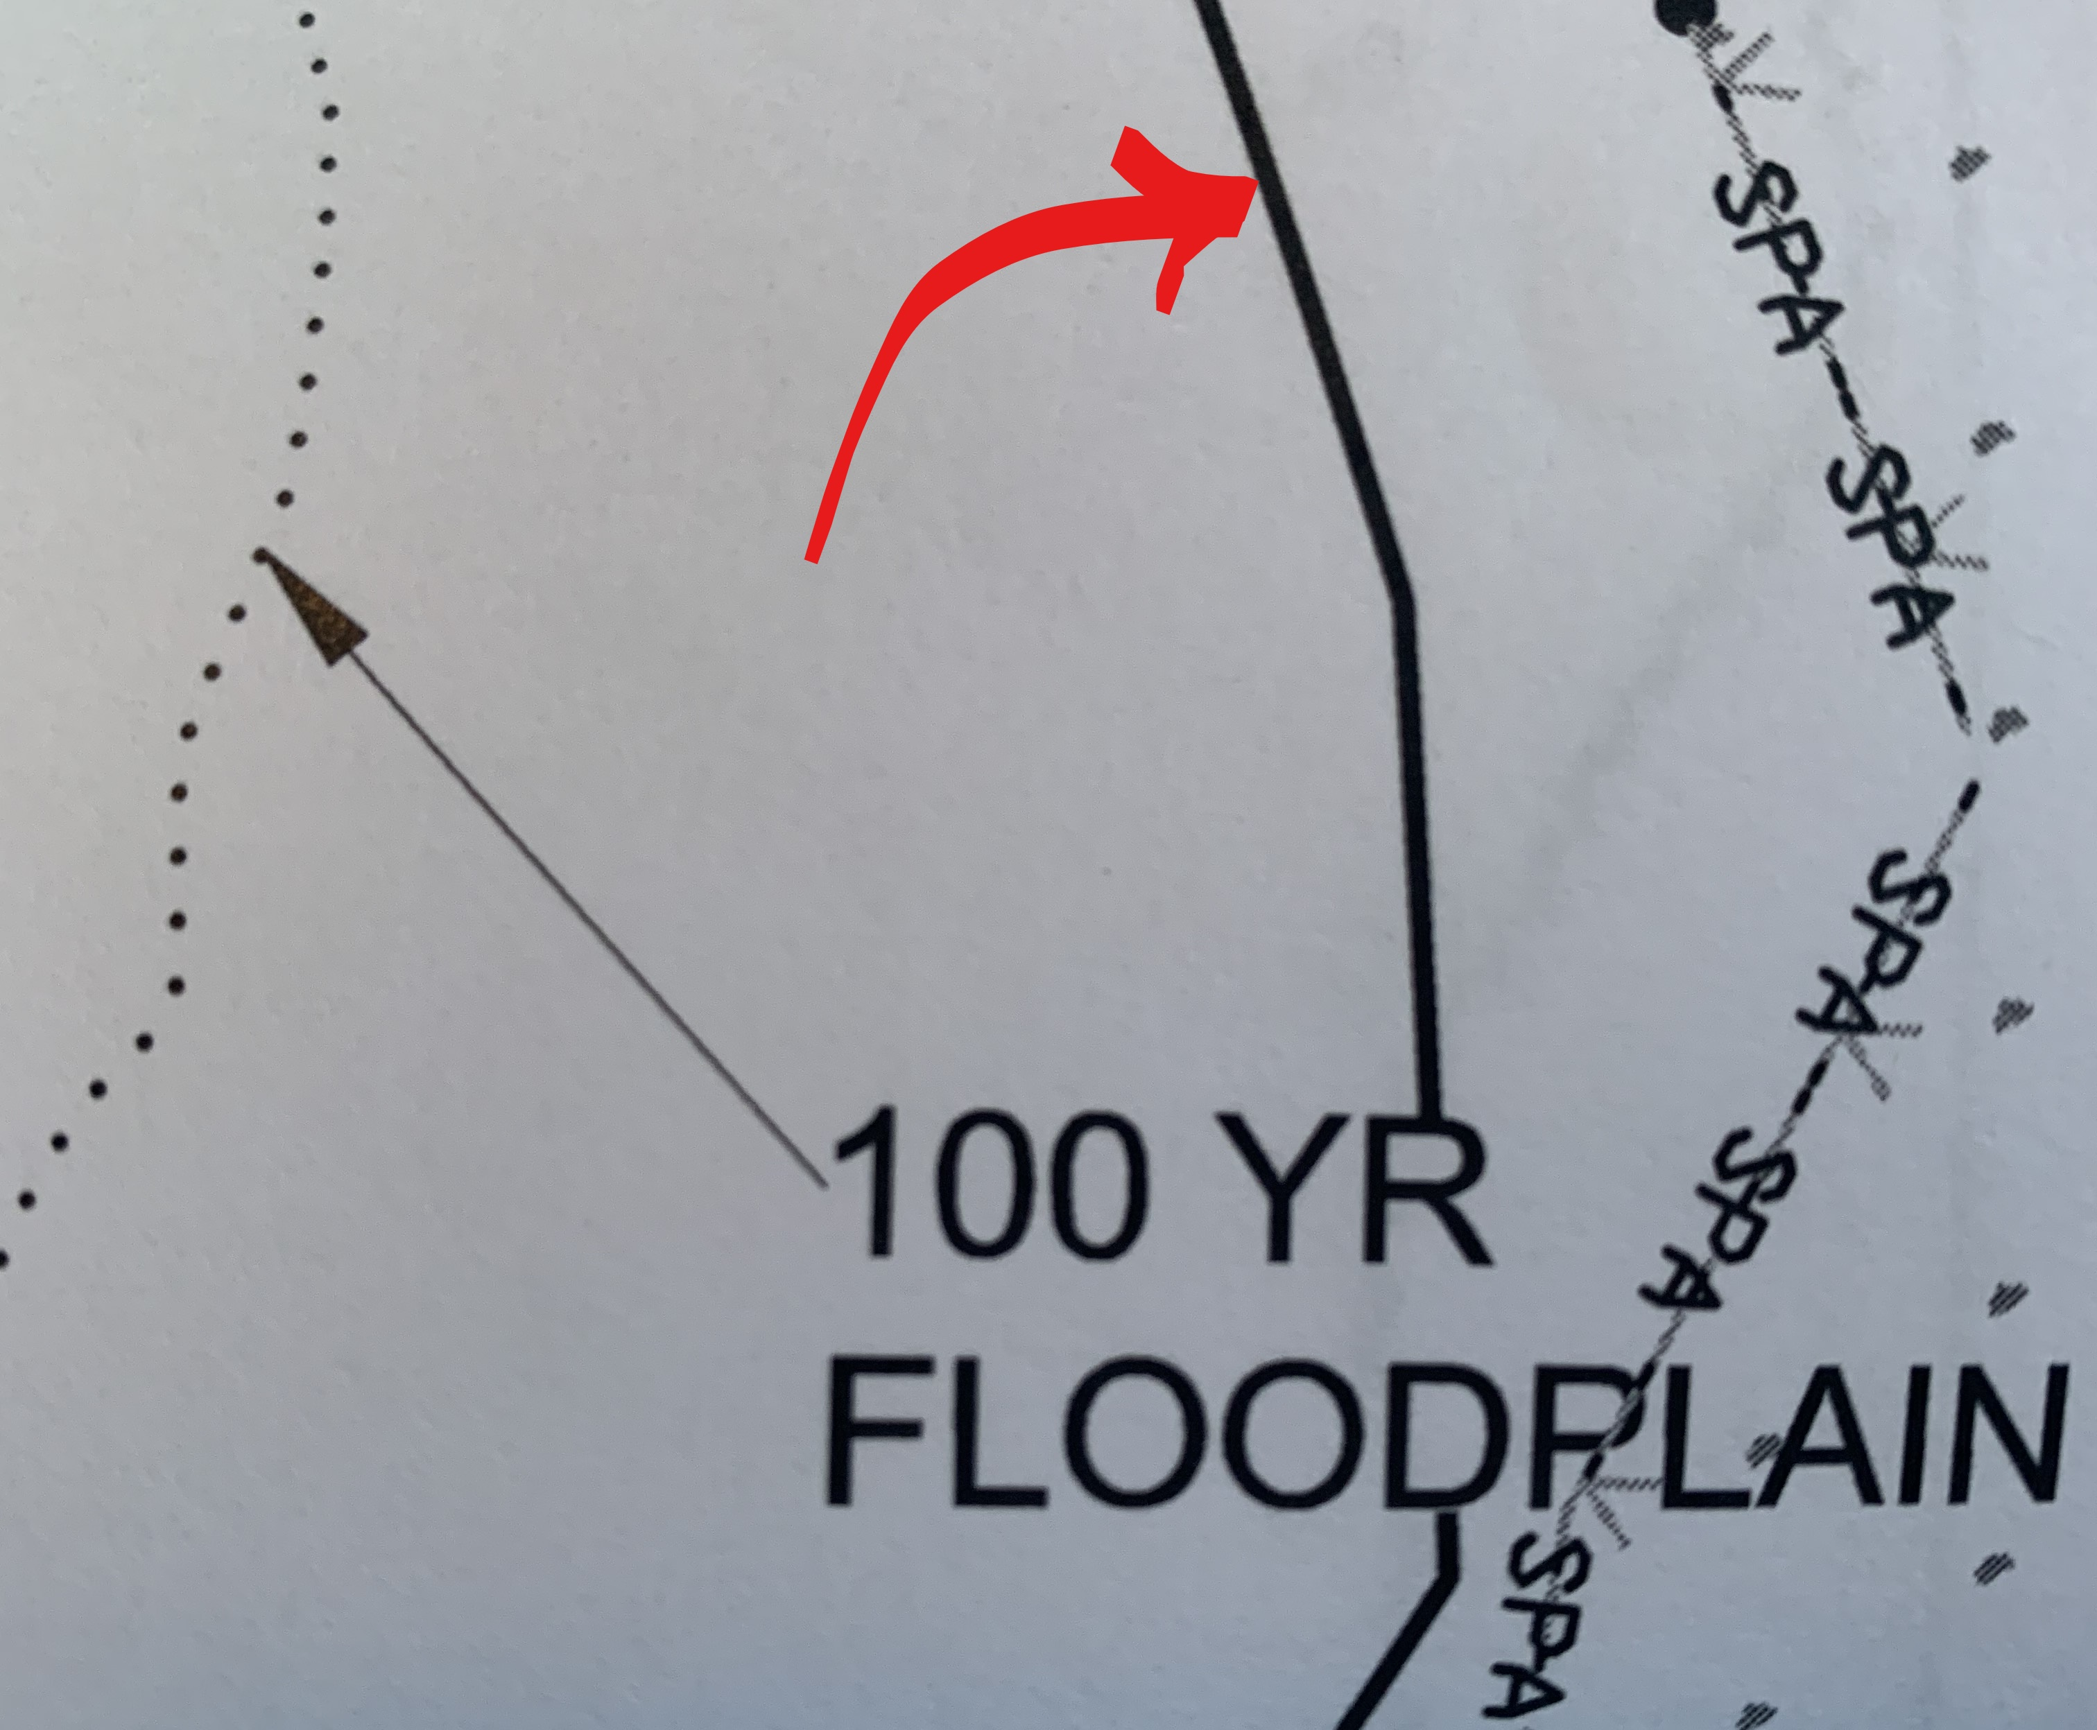

Reviewed by: Doug Young
Date Reviewed: 3 September 2021
Phone Number: (804) 501-5851
Revised 5/18/21

